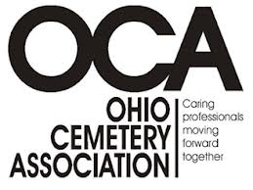
219 Webbshaw Drive
Centerville, OH 45458
937 885 0283 (Office)
937 885 4512 (Fax)

REGISTRATION

Crematory Operator Certification Seminar

Registration Fee: $395.00 per person includes Continental Breakfast/Lunch & Breaks

Name___________________________________________________________________

Name___________________________________________________________________

Name___________________________________________________________________

Attach separate sheet of paper if registering more than three people.

Company________________________________________________________________

Address_________________________________________________________________

City_________________________State___________Zip_____________

Phone _______________________________Fax_____________________

Email__________________________________

If needed, hotel reservations can be made directly with the Embassy Suites Hotel, 5100 Upper Metro Place, Dublin, Oh by calling (614)790 9000. Rate 113.00 plus tax

Please complete this form and return with check made payable to:
Ohio Cemetery Association
219 Webbshaw Drive
Centerville, OH 45458

If you have any questions feel free to contact Rufus Slade at (937) 673-1952 or email address, rufus@woodlandcemetery.org .
Return your registration promptly to assure your place as seating is limited.
Registration deadline: July 30, 2013

20130228ccertr

